Jira
26/12/2025
Jira Software 11.3.1, released in December 2025.
Jira is a project management and issue-tracking tool developed by Atlassian.
It helps teams plan, track, manage, and deliver work in an organized way.
Originally built for bug tracking, Jira is now widely used for:
- Software development
- Agile & Scrum projects
- IT support
- Business task management
Jira history & ecosystem
Jira was developed by Atlassian
Released in 2002 as a bug-tracking tool
Later evolved into a full project and workflow management platform
Jira Ecosystem includes:
- Jira Software (for development teams)
- Jira Service Management (for IT & support)
- Jira Work Management (for business teams)
- Confluence (documentation)
- Bitbucket (code repository)
Thousands of plugins from Atlassian Marketplace
Why is Jira a Powerful Tool for Teams & Organizations?
- Centralized Work Management
- Supports Agile & Scrum
- Transparency & Accountability
- Customizable for Any Team
- Strong Reporting & Insights
- Integrates with Other Tools

Jira Terminologies (Most Important Ones)
Issue
A single unit of work in Jira
Examples: Bug, Task, Story, Ticket
Issue Types
Different kinds of work:
- Bug – A defect or error
- Task – A simple piece of work
- Story – A user requirement
- Epic – A large feature that contains multiple stories
Project
A container for issues
Example: Website Development Project
Workflow
The life cycle of an issue
Example:
To Do → In Progress → Testing → Done
Board
Visual view of work:
- Scrum Board – Sprint-based
- Kanban Board – Continuous flow
Sprint
A fixed time period (usually 1–2 weeks) to complete planned work
Backlog
A list of pending and upcoming work not yet started
Epic
A large feature or goal broken into smaller stories
Story Points
Used to estimate effort, not time
Assignee
The person responsible for the issue
Reporter
The person who created the issue
Status
Current stage of an issue
Example: Open, In Progress, Done
Priority
Importance of an issue
Example: High, Medium, Low
Resolution
How the issue was completed
Example: Fixed, Done, Won’t Fix
A Jira Project is a workspace where teams plan, track, and manage work.
Each project contains:
- Issues (tasks, bugs, stories)
- Workflows
- Boards
- Permissions
- Reports
Jira projects are mainly of two types:
1.Team-Managed Projects: Small teams that want quick setup and flexibility.
Key Features
- Managed entirely by the project team
- No dependency on Jira administrators
- Simple configuration
- Project-specific workflows and issue types
Characteristics
- Easy and fast to create
- Limited customization
- Settings apply only to that project
- Best for independent teams
2.Company-Managed Projects: Large organizations with standardized processes.
Key Features
- Managed by Jira admins
- Uses shared configurations
- Highly customizable
- Strong governance and control
Characteristics
- Complex but powerful setup
- Workflows, issue types, and schemes can be reused
- Consistent processes across teams
- Better reporting and scalability
Jira Project Types – Full Comparison Table
Aspect | Team-Managed Project | Company-Managed Project
Target Users | Small, independent teams | Large teams / enterprises
Setup Speed | Very fast (minutes) | Slower, more setup required
Admin Dependency | Not required | Required (Jira Admin)
UI Complexity | Simple and clean | Advanced and detailed
Configuration Location | Inside the project | Global admin settings
Ease of Use | Beginner-friendly | Requires Jira knowledge
Customization Level | Limited | Extensive
Project Autonomy | High (team controls everything) | Low (admin controls)
Workflow Management | Project-specific workflows | Shared workflows across projects
Workflow Reuse | ❌ Not reusable | ✅ Reusable
Issue Types | Created per project | Managed via schemes
Screens | Auto-managed by Jira | Fully customizable
Fields | Project-specific fields | Shared/global fields
Field Reuse | ❌ No | ✅ Yes
Schemes Used | ❌ No schemes | ✅ Workflow, Field, Screen, Permission schemes
Permissions | Simple role-based | Permission schemes
Roles | Basic project roles | Advanced roles & permissions
Boards | One board per project | Multiple boards possible
Reports | Basic reports | Advanced reports
Automation | Limited automation | Advanced automation
Integration Flexibility | Limited | Extensive
Scalability | Low to Medium | High
Governance & Control | Team-level control | Organization-level control
Standardization | Not enforced | Enforced across projects
Change Impact | Affects only that project | Can affect multiple projects
Maintenance Effort | Low | High
Learning Curve | Low | Steep
Best Use Case | Quick starts, simple projects | Complex, long-term projects

Jira Project (Space) Templates
These templates are used to create a Jira project with predefined boards (Scrum / Kanban), workflows, issue types, and reports.

Made for you: Jira’s smart recommendations based on your role and previous projects.
Creates: Usually Scrum or Kanban board, Standard issue types, Default Agile workflow
Used for: Quick project creation when you don’t want to choose manually.

Bundles: A combination of multiple project setups in one project.
Creates: Multiple boards (Scrum + Kanban), Shared issues and workflows
Used for: Teams that need planning + continuous work in the same project.

Custom templates (Enterprise): Organization-defined Jira templates.
Creates: Pre-approved workflows, Standard issue types, Company policies & automation
Used for: Enterprises that want strict standards across all projects.

Software Development: Templates for building software using Agile methods.
Creates: Scrum or Kanban board, Backlog & sprints, Issue types: Story, Bug, Task, Agile reports (Burndown, Velocity)
Used for:
Development teams, Agile/Scrum teams.
Service Management: IT service and support project templates.
Creates: Queues, Request types, SLAs, Incident & service workflows
Used for: IT support, Helpdesk, Operations teams.

Work Management: General task and project tracking.
Creates: Simple Kanban board,Task-based workflows
Used for: Business teams, operations, coordination work.
Product Management: Templates focused on feature and roadmap tracking.
Creates: Backlog, Epics, Roadmap views, Scrum or Kanban boards
Used for: Product managers and product teams.
Marketing: Campaign and content workflow templates.
Creates: Kanban boards, Approval workflows, Marketing issue types
Used for: Marketing teams managing campaigns.
Human Resources: People and HR workflow templates.
Creates: Hiring pipelines, Onboarding workflows, Approval steps
Used for: HR teams and recruiters.
Finance: Templates for financial processes.
Creates: Approval workflows,Budget tracking issues
Used for: Finance and accounting teams.
Design: Creative and design request management.
Creates: Design request board, Review & approval workflows
Used for: UX, UI, creative teams.
Personal: Simple personal task management.
Creates: Lightweight Kanban board, Minimal workflow
Used for: Individual task tracking.
Operations: Operational and process tracking.
Creates: Ops workflows, Incident / task boards
Used for: Operations and support teams.

A project is a temporary effort created to achieve a specific goal or outcome within a defined time, scope, and resources.
A process is a set of repeatable steps followed to achieve a consistent result.
Method is the specific way or technique used to perform a task within a process.

In Jira, an “Issue Type” simply means the category or kind of work item you are tracking in your project.

Issue Type | Description | Hierarchy / Relationship
Epic | A large body of work that can be broken down into multiple stories/tasks. | Top-level; contains Stories or Tasks
Story | A feature or functionality from the user’s perspective (user story). | Usually part of an Epic; can contain Subtasks
Task | Work that needs to be done, not necessarily a user story; technical or non-feature work. | Can be part of Epic or standalone; can have Subtasks
Bug | A defect or issue in the product that needs fixing. | Can be part of Epic or standalone; can have Subtasks
Subtask | A smaller piece of work that belongs to a Story, Task, or Bug. | Child of Story, Task, or Bug; cannot exist independently
Real-time Workflow / Order Example:
- Epic: Implement User Authentication
- Stories under Epic:
  - Story 1: User can register with email
  - Story 2: User can log in
  - Story 3: User can reset password
- Tasks / Bugs under Stories:
  - Task: Set up DB schema for user accounts
  - Task: Integrate OAuth login
  - Bug: Login button crashes app on Android

- Subtasks:
  - Write unit tests for login API
  - Write UI test for login button
  - Update API documentation
Key Point: Epics > Stories/Tasks/Bugs > Subtasks. This hierarchy helps teams track large features, break them into smaller work, and assign/manage efficiently

Sample work of kanban
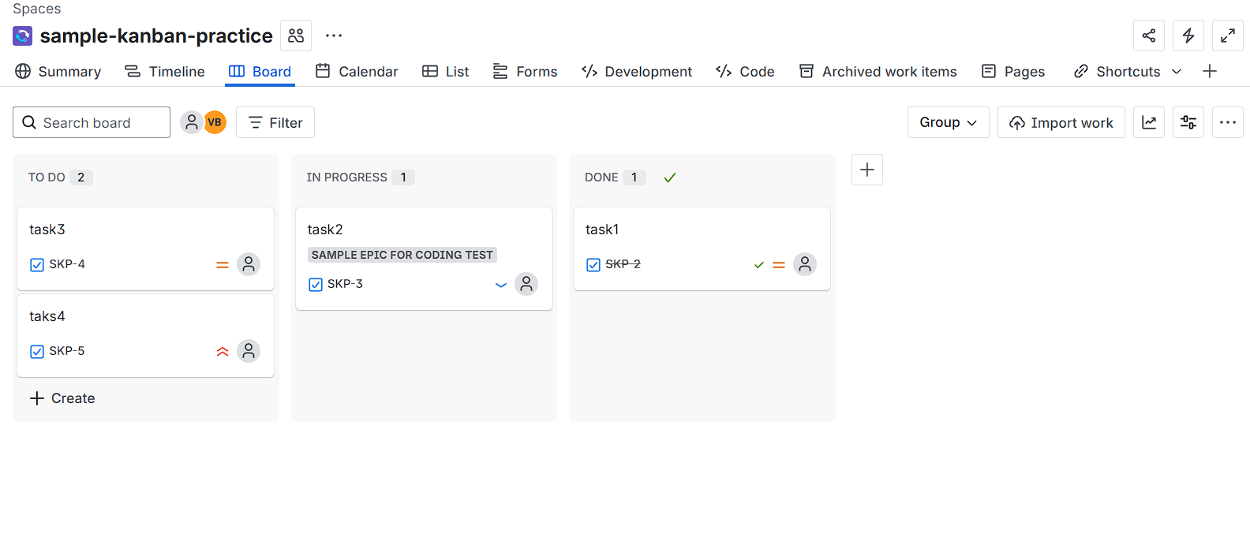

Sample work of scrum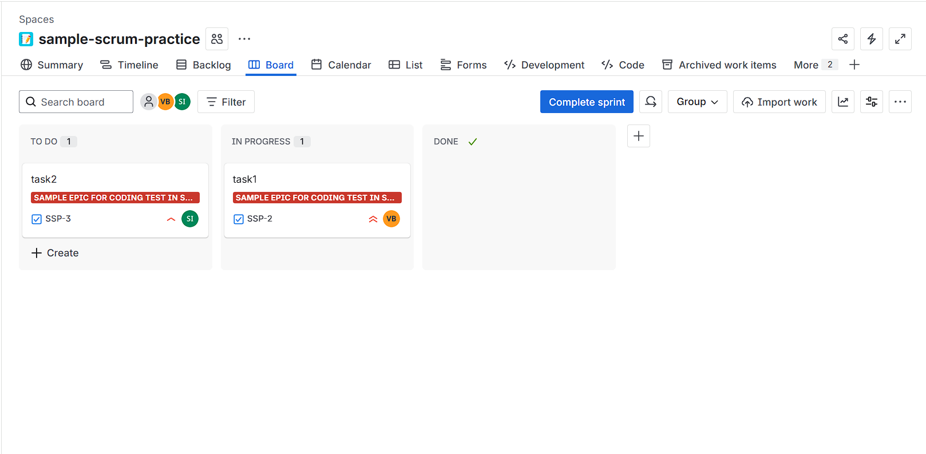

What is Scrum?
Scrum is an Agile framework where work is delivered in fixed-length iterations called sprints.
Scrum Board Purpose
- Plan work in advance
- Deliver features in short cycles
- Inspect & adapt regularly
Sprint
- Duration: 1–4 weeks (most teams use 2 weeks)
- Work is committed at sprint start
- Scope should not change during sprint
Scrum Board Flow
Backlog → Selected for Sprint → To Do → In Progress → Done

Scrum Roles
Role | Responsibility
Product Owner | Defines requirements, prioritizes backlog
Scrum Master | Facilitates Scrum, removes blockers
Development Team | Builds, tests, delivers product

Scrum Meetings (Ceremonies)
Meeting | When | Duration | Purpose
Sprint Planning | Start of sprint | 1–2 hrs | Decide what to build
Daily Stand-up | Daily | 15 mins | Progress, blockers
Sprint Review | End of sprint | 1 hr | Demo completed work
Sprint Retrospective | End of sprint | 45–60 mins | Improve process

When to Use Scrum
- Clear requirements
- Feature development
- Predictable delivery
- Product-based teams
What is Kanban?
Kanban is an Agile method focused on continuous delivery without fixed sprints.
Kanban Board Purpose
- Visualize work
- Limit work in progress (WIP)
- Improve flow efficiency
Kanban Board Flow
To Do → In Progress → Review → Done
Key Kanban Concepts
Concept | Meaning
No Sprints | Work flows continuously
WIP Limits | Limit items in each column
Cycle Time | Time taken to complete work
Continuous Delivery | Release anytime
WIP=Work In Progress
When to Use Kanban
Support & maintenance teams, Bug fixing, Continuous work, Unpredictable tasks

What is Backlog?
The Backlog is a prioritized list of all work that needs to be done in the project.
What you see in Backlog
- Epics
- Stories / Tasks / Bugs
- Priority order
- Sprint planning area
Who mainly uses it
- Product Owner → prioritizes work
- Team → prepares upcoming work
Purpose
- Plan future work
- Refine and estimate issues
- Select issues for next sprint
What is Board View?
The Board shows issues as cards moving across columns, representing the workflow.
Board Types
- Scrum Board → Sprint-based
- Kanban Board → Continuous flow
Typical Columns
To Do → In Progress → Review → Done
Who uses it
- Entire team (daily)
Purpose
- Track work status
- Visualize progress
- Identify blockers & bottlenecks

